https://www.dineshonjava.com/hibernate-3-on-baby-steps/

Hibernate Tutorial for Beginners Learn step by step
This hibernate tutorial provide step by step instructions on using Hibernate. Hibernate is popular open source object relational mapping tool for Java platform. It provides powerful, ultra-high performance object/relational persistence and query service for Java.

Actually Hibernate is much more than ORM Tool (Object – Relational Mapping) because today its provide lots of features in the persistence data layer.
ORM means Objects to Relational Mapping i.e. Java Persistence Objects are mapped to Relational databases by using ORM tools.

HIBERNATE :
- An ORM Tool
- Used in the Data layer of the applications
- Implements JPA (Java Persistence API) i.e its have set of standards that have been prescribed for any persistence of any implementation need to be satisfied to persistence rules in the java that given minimal change of codes means follow the all rules of persistence in later if any change in the ORM tools with minimum change in the code.

Why We Have to Use ORM Tools?
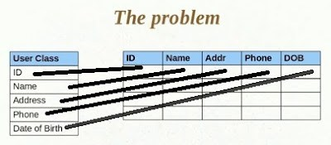
Here there is one problem to object save in to relational database each entity of the object save individually to the database table in the associated columns. It is more times taken and complex in case of lots of user objects to be save into the database table

Hibernate Architecture
In this Hibernate Architecture tutorial we include all components. Hibernate Architecture is layered with many objects such persistent object, session factory, transaction factory, connection factory, session, transaction etc. Let see below diagram describing some basic hibernate functionality.
Configuration
It represents a configuration or properties file for Hibernate. The Configuration object is usually created once during application initialization. The Configuration object reads and establishes the properties Hibernate uses to get connected to a database and configure itself for work. A Configuration object is used to create a SessionFactory and then typically is discarded.
SessionFactory
The SessionFactory is created from a Configuration object, and as its name implies it is a factory for Session objects.The SessionFactory is an expensive object to create. It, like the Configuration object, is usually created during application start up. However, unlike the Configuration object, It should be created once and kept for later use.
The SessionFactory object is used by all the threads of an application. It is a thread safe object. One SessionFactory object is created per database. Multiple SessionFactory objects (each requiring a separate configuration) are created when connecting to multiple databases. The SessionFactory can also provide caching of persistent objects. -Dinesh
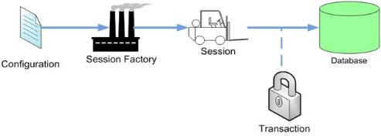
Session
Session objects provide the main interface to accomplish work with the database. Persistent objects are saved and retrieved through a Session object. A Session object is lightweight and inexpensive to create. A Session object does the work of getting a physical connection to the database. Session objects maintain a cache for a single application thread (request).
Session objects are not thread safe. Therefore, session objects should not be kept open for a long time.Applications create and destroy these as needed. Typically, they are created to complete a single unit of work, but may span many units. -Dinesh
Transaction
it represents unit of works.
Query and Criteria
These objects are used to retrieve (and recreate) persistent objects.

UserDetails.java

package com.sdnext.hibernate.tutorial.dto;
import java.util.Date;
import javax.persistence.Entity;
import javax.persistence.Id;
@Entity
public class UserDetails
{
@Id
private int userId;
private String userName;
public int getUserId() {
return userId;
}
public void setUserId(int userId) {
this.userId = userId;
}
public String getUserName() {
return userName;
}
public void setUserName(String userName) {
this.userName = userName;
}
}
Here @Entity means it telling hibernate this class treat as entity and need to save it the database.
and @ID means it telling hibernate this property treat as primary key of the table.
these are two minimum required annotation we have use for saving the object in the database.
Step 3: HibernateTestDemo.java
package com.sdnext.hibernate.tutorial;
import java.util.Date;
import org.hibernate.Session;
import org.hibernate.SessionFactory;
import org.hibernate.cfg.AnnotationConfiguration;
import com.sdnext.hibernate.tutorial.dto.UserDetails;
public class HibernateTestDemo {
public static void main(String[] args)
{
//Create the model object
UserDetails user = new UserDetails();
user.setUserId(1);
user.setUserName(“Dinesh Rajput”);
// Create Session Factory Object using Annotation Configuration
SessionFactory sessionFactory = new AnnotationConfiguration().configure().buildSessionFactory();
//Create Session object from session factory object
Session session = sessionFactory.openSession();
session.beginTransaction();
//Use the session to save model objects
session.save(user);
session.getTransaction().commit();
session.close();
}
}

1.<hibernate-mapping> element:
The first or root element of hibernate mapping document is <hibernate-mapping> element. Between the <hibernate-mapping> tag class element(s) are present.
2. <class> element:
The <Class> element maps the class object with corresponding entity in the database. It also tells what table in the database has to access and what column in that table it should use. Within one <hibernate-mapping> element, several <class> mappings are possible.
3.<id> element:
The <id> element in unique identifier to identify an object. In fact <id> element map with the primary key of the table. In our code :
<id name=”userId” type=”long” column=”ID” >
primary key maps to the ID field of the table UserDetails. Following is the attributes of <id> element
- name – Property name of the persistence model class
- type – The java data type used for that property
- column – Name of the column for that property of the persistence object
- unsaved-value – This is the value used to determine if a class has been made persistent. If the value of the id attribute is null, then it means that this object has not been persisted.
4.<generator> element:
Used to create primary key for new record, there are some commonly used generators type given below…
- Increment- used to generate primary keys of type long, short or int that are unique only.
- Sequence – used to generate primary keys for DB2, Oracle, SAP Database.
- Assigned – is used when application code generates the primary key.
- Native – selects identity, sequence or hilo depending upon the capabilities of the underlying db.
- Identity – supports identity columns in DB2, MySQL, MS SQL Server, Sybase and HypersonicSQL. The returned identifier is of type long, short or int.
- Uuid – Unique use ID of 128 bits generated from using algorithm and return type is String
- hilo – generated by the hi/lo Algorithm
- seqhilo – generated by the hi/lo Algorithm according to sequence of database
- select – select from database triggered value
- foreign – associated with the other model objects
5.<property> element: define standard Java attributes and their mapping into database schema.
That is all about the mapping file for O/R mapping. I hope you was understand its all elements and its working in the hibernate.

Transient, Persistent and Detached Objects in Hibernate
In couple of previous chapters we have seen that every entity object are passed to three states of the object before saving and updating the row in the database table as per as given in the following picture
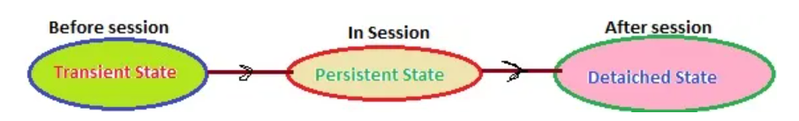

1. Transient State:
A New instance of a persistent class which is not associated with a Session, has no representation in the database and no identifier value is considered transient by Hibernate:
UserDetail user = new UserDetail();
user.setUserName("Dinesh Rajput");
// user is in a transient state

2. Persistent State:
A persistent instance has a representation in the database , an identifier value and is associated with a Session. You can make a transient instance persistent by associating it with a Session:
Long id = (Long) session.save(user);
// user is now in a persistent state

3. Detached State:
Now, if we close the Hibernate Session, the persistent instance will become a detached instance: it isn’t attached to a Session anymore (but can still be modified and reattached to a new Session later though).
session.close();
//user in detached state

Difference between Transient and Detached States:
Transient objects do not have association with the databases and session objects. They are simple objects and not persisted to the database. Once the last reference is lost, that means the object itself is lost. And of course , garbage collected. The commits and rollbacks will have no effects on these objects. They can become into persistent objects through the save method calls of Session object.
The detached object have corresponding entries in the database. These are persistent and not connected to the Session object. These objects have the synchronized data with the database when the session was closed. Since then, the change may be done in the database which makes this object stale. The detached object can be reattached after certain time to another object in order to become persistent again.

Why WE USE HQL?
Although it is possible to use native SQL queries directly with a Hibernate-based persistence layer, it is more efficient to use HQL instead. The reasons of choosing HQL over the other two methods are given below.
- HQL allows representing SQL queries in object-oriented terms—by using objects and properties of objects.
- Instead of returning plain data, HQL queries return the query result(s) in the form of object(s)/tuples of object(s) that are ready to be accessed, operated upon, and manipulated programmatically. This approach does away with the routine task of creating and populating objects from scratch with the “resultset” retrieved from database queried.
- HQL fully supports polymorphic queries. That is, along with the object to be returned as a query result, all child objects (objects of subclasses) of the given object shall be returned.
- HQL is easy to learn and implement, as its syntax and features are very similar to SQL.
- HQL contains many advance features such as pagination, fetch join with dynamic profiling, and so forth, as compared to SQL.
- HQL facilitates writing database-type independent queries that are converted to the native SQL dialect of the underlying database at runtime. This approach helps tap the extra features the native SQL query provides, without using a non-standard native SQL query.

HQL Syntax>>
As described earlier, most of HQL’s syntax and features are very similar to SQL. An HQL query may consist of following elements:
- Clauses
- Aggregate functions
- Subqueries

Clauses in the HQL are:
- from
- select
- where
- order by
- group by

Aggregate functions are:
- avg(…), sum(…), min(…), max(…)
- count(*)
- count(…), count(distinct …), count(all…)

Subqueries
Subqueries are nothing but its a query within another query. Hibernate supports Subqueries if the underlying database supports it.

Table A: HQL Clauses with their description, syntax, and examples.
Clause | Description | Syntax | Example
from | The simplest form of an HQL query. Specifies the object whose instances are to be returned as the query result. Commonly used with the select clause. | from object [as object_alias]* object_alias simply means another name given to refer to an object for convenience. | from UserDetails as user  Will return all instances of object UserDetails.
select | Specifies objects and properties to be returned in the query result set. Used in conjunction with the from clause. | select [object.]property | select user.userName from UserDetails as user  Advertisements  Will return all values of userName in all instances of UserDetails.
where | Specifies the conditions that should be satisfied by the instances returned as the query result. Used with select and/or from clause. | where condition  Here, condition is a combination of logical, relational operators i.e. =, >, AND, NOT etc. | from UserDetails as user where user.userId > 2  Will return all instances of user in UserDetails whose correspondinguser.userId values are greater than 2.
order by | Specifies the order (ascending/descending) in which the properties of objects returned as query results should be listed. Used with the select and from clauses. | order by object0.property0 [asc|desc][, object1.property0]…  By default, order is ascending unless specified otherwise. | from UserDetails as user order by userId asc  Will return a list of all instances of user in ascending order of corresponding userId values.
group by | Specifies the grouping criteria using objects properties, by which the list of objects returned as a query result should be grouped together. Used with the select and/or from clause. | group by object0.property0[, object1.property0]… | select userId from UserDetails as user group by user.userId  Will return list of all userId instances from user grouped by corresponding values of user.
SQL Injection and Parameter Binding in Hibernate

SQL Injection and Parameter Binding in Hibernate
In this tutorial of SQL Injection and Parameter Binding in Hibernate we will discuss about SQL inject and its demerits and also describe Parameter binding, it means is way to bind parameter with SQL to use in the hibernate for particular criteria.

SQL Injection:
Injecting the value to the SQL statement. SQL injection refers to the act of someone inserting a MySQL statement to be run on your database without your knowledge. Injection usually occurs when you ask a user for input, like their name, and instead of a name they give you a MySQL statement that you will unknowingly run on your database.
Normal: ” SELECT * FROM student WHERE studentName= ‘sweety'”
Injection: “SELECT * FROM student WHERE studentName= ” +studentName
It is a very common misconception that ORM solutions, like hibernate, are SQL Injection proof. Hibernate allows the use of “native SQL” and defines a proprietary query language, named, HQL the former is prone to SQL Injection and the later is prone to HQL injection.
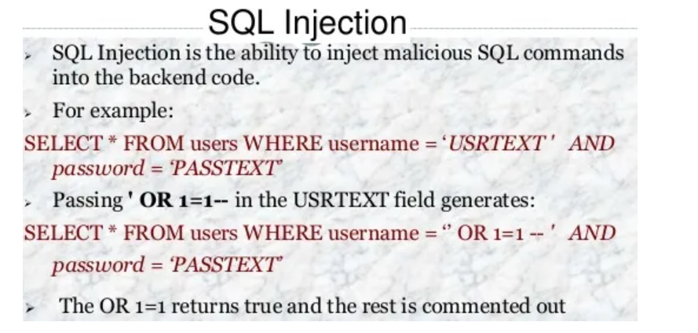

Parameter Binding:
A bind variable is a named placeholder (preceded by a colon) that is embedded in the query string in place of a literal. The actual value is substituted at runtime using the setParameter() method.
Without parameter binding, you have to concatenate the parameter String like this (bad code) :
String hql = "from Student student where student.studentName = '" + studentName+ "'";
Query query = session.createQuery(hql);
List result = query.list();

Pass an unchecked value from user input to the database will raise security concern, because it can easy get hack by SQL injection. You have to avoid the above bad code and using parameter binding instead.

Hibernate parameter binding
There are two ways to parameter binding :
- Named parameters binding
- Positional parameters binding.

1. Named Parameters Binding:
This is the most common and user friendly way. It use colon followed by a parameter name (:example) to define a named parameter. See examples…

Example 1 – setParameter
The setParameter is smart enough to discover the parameter data type for you.
String hql = "from Student student where student.rollNumber= :rollNumber";
Query query = session.createQuery(hql);
query.setParameter("rollNumber", "3");
List result = query.list();
Example 2 – setString
You can use setString to tell Hibernate this parameter date type is String.
String hql = "from Student student where student.studentName= :studentName";
Query query = session.createQuery(hql);
query.setString("studentName", "Sweety Rajput");
List result = query.list();

Example 3 – setProperties
This feature is great ! You can pass an object into the parameter binding. Hibernate will automatic check the object’s properties and match with the colon parameter.
Student student= new Student();
student.setCourse("MCA");
String hql = "from Student student where student.course= :course";
Query query = session.createQuery(hql);
query .setProperties(student);
List result = query.list();

2. Positional parameters
It’s use question mark (?) to define a named parameter, and you have to set your parameter according to the position sequence. See example…
String hql = "from Student student where student.course= ? and student.studentName = ?";
Query query = session.createQuery(hql);
query.setString(0, "MCA");
query.setParameter(1, "Dinesh Rajput")
List result = query.list();
In Hibernate parameter binding, i would recommend always go for “Named parameters”, as it’s more easy to maintain, and the compiled SQL statement can be reuse (if only bind parameters change) to increase the performance.

Named Queries in Hibernate Example
Often times, developer like to put HQL string literals scatter all over the Java code, this method is hard to maintain and look ugly. Fortunately, Hibernate come out a technique called “named queries” , it lets developer to put all HQL into the XML mapping file or via annotation.

Named Query
Named Query is very useful concept in hibernate. It lets you separate queries from coding section of the application to the mapping xml file(.hbm files). The query is given unique name for the entire application. The application can use the query by using the name of the query. This way the application is able to use the same query multiple times without writing the same query multiple times.

1. XML mapping file:
student.hbm.xml
Native SQL in mapping file:
<hibernate-mapping>
<class name="com.sdnext.hibernate.tutorial.dto.Student" table="STUDENT">
<id column="ID" name="id" type="int">
<generator class="increment">

</generator></id>
<property name="rollNumber" type="int">
<column name="ROLL_NUMBER">
</column></property>
<property name="studentName" type="String">
<column name="STUDENT_NAME"></column>
</property>
<property name="course" type="String">
<column name="COURSE"></column>
</property>
</class>

<sql-query name="findStudentByRollNumber">
<return alias="student" class="com.sdnext.hibernate.tutorial.dto.Student">
<!--[CDATA[
select * from Student student where student.rollNumber = :rollNumber
]]-->
</return>
</sql-query>
</hibernate-mapping>

HQL in mapping file
<hibernate-mapping>
<class name="com.sdnext.hibernate.tutorial.dto.Student" table="STUDENT">
<id column="ID" name="id" type="int">
<generator class="increment">

</generator></id>
<property name="rollNumber" type="int">
<column name="ROLL_NUMBER">
</column></property>
<property name="studentName" type="String">
<column name="STUDENT_NAME"></column>
</property>
<property name="course" type="String">
<column name="COURSE"></column>
</property>
</class>

<query name="findStudentByRollNumber">
<!--[CDATA[
from Student student where student.rollNumber = :rollNumber
]]-->
</query>
</hibernate-mapping>
You can place a named query inside hibernate-mapping element, but do not put before the class element, Hibernate will prompt invalid mapping file, all your named queries have to put after the class element.
hibernate.cfg.xml
<hibernate-configuration>
<session-factory>
<!-- Database connection settings -->
<property name="connection.driver_class">com.mysql.jdbc.Driver</property>
<property name="connection.url">jdbc:mysql://localhost:3306/hibernateDB2</property>
<property name="connection.username">root</property>
<property name="connection.password">root</property>

<!-- JDBC connection pool (use the built-in) -->
<property name="connection.pool_size">1</property>

<!-- SQL dialect -->
<property name="dialect">org.hibernate.dialect.MySQLDialect</property>

<!-- Enable Hibernate's automatic session context management -->
<property name="current_session_context_class">thread</property>

<!-- Disable the second-level cache -->
<property name="cache.provider_class">org.hibernate.cache.NoCacheProvider</property>

<!-- Echo all executed SQL to stdout -->
<property name="show_sql">true</property>

<!-- Drop and re-create the database schema on startup -->
<property name="hbm2ddl.auto">update</property>

<mapping resource="student.hbm.xml">

</mapping></session-factory>
</hibernate-configuration>
HibernateTestDemo.java
package com.sdnext.hibernate.tutorial;

import java.util.List;

import org.hibernate.Query;
import org.hibernate.Session;
import org.hibernate.SessionFactory;
import org.hibernate.cfg.Configuration;

import com.sdnext.hibernate.tutorial.dto.Student;

public class HibernateTestDemo {
/**
* @param args
*/
public static void main(String[] args)
{
SessionFactory sessionFactory = new Configuration().configure().buildSessionFactory();
Session session = sessionFactory.openSession();
session.beginTransaction();

Query query = session.getNamedQuery("findStudentByRollNumber").setInteger("rollNumber", 3);

List students = query.list();
for(Student student : students)
{
System.out.println(student);
}
session.getTransaction().commit();
session.close();
}
}

2. Annotation:
HQL in annotation
@NamedQueries({
@NamedQuery(
name = "findStudentByRollNumber",
query = "from Student student where student.rollNumber = :rollNumber"
)
})
@Entity
@Table(name = "STUDENT")
public class Student implements java.io.Serializable {
...
Native SQL in annotation
@NamedNativeQueries({
@NamedNativeQuery(
name = "findStudentByRollNumber",
query = "select * from Student student where student.rollNumber = :rollNumbe"
resultClass = Student.class
)
})
@Entity
@Table(name = "STUDENT")
public class Student implements java.io.Serializable {
...
In native SQL, you have to declare the ‘resultClass‘ to let Hibernate know what is the return type, failed to do it will caused the exception “org.hibernate.cfg.NotYetImplementedException: Pure native scalar queries are not yet supported”.
Example:
Student.java
Advertisements
package com.sdnext.hibernate.tutorial.dto;

import java.io.Serializable;

import javax.persistence.Column;
import javax.persistence.Entity;
import javax.persistence.GeneratedValue;
import javax.persistence.GenerationType;
import javax.persistence.Id;
import javax.persistence.NamedQueries;
import javax.persistence.NamedQuery;
import javax.persistence.Table;

@NamedQueries({
@NamedQuery(
name = "findStudentByRollNumber",
query = "from Student student where student.rollNumber = :rollNumber"
)
})
@Entity
@Table(name="STUDENT")
public class Student implements Serializable
{
/**
* serialVersionUID
*/
private static final long serialVersionUID = 8633415090390966715L;
@Id
@Column(name="ID")
@GeneratedValue(strategy=GenerationType.AUTO)
private int id;
@Column(name="STUDENT_NAME")
private String studentName;
@Column(name="ROLL_NUMBER")
private int rollNumber;
@Column(name="COURSE")
private String course;
public int getId() {
return id;
}
public void setId(int id) {
this.id = id;
}
public String getStudentName() {
return studentName;
}
public void setStudentName(String studentName) {
this.studentName = studentName;
}
public int getRollNumber() {
return rollNumber;
}
public void setRollNumber(int rollNumber) {
this.rollNumber = rollNumber;
}
public String getCourse() {
return course;
}
public void setCourse(String course) {
this.course = course;
}
public String toString()
{
return "ROLL Number: "+rollNumber+"| Name: "+studentName+"| Course: "+course;
}
}
hibernate.cfg.xml
<hibernate-configuration>
<session-factory>
<!-- Database connection settings -->
<property name="connection.driver_class">com.mysql.jdbc.Driver</property>
<property name="connection.url">jdbc:mysql://localhost:3306/hibernateDB2</property>
<property name="connection.username">root</property>
<property name="connection.password">root</property>

<!-- JDBC connection pool (use the built-in) -->
<property name="connection.pool_size">1</property>

<!-- SQL dialect -->
<property name="dialect">org.hibernate.dialect.MySQLDialect</property>

<!-- Enable Hibernate's automatic session context management -->
<property name="current_session_context_class">thread</property>

<!-- Disable the second-level cache -->
<property name="cache.provider_class">org.hibernate.cache.NoCacheProvider</property>

<!-- Echo all executed SQL to stdout -->
<property name="show_sql">true</property>

<!-- Drop and re-create the database schema on startup -->
<property name="hbm2ddl.auto">update</property>

<mapping class="com.sdnext.hibernate.tutorial.dto.Student">

</mapping></session-factory>
</hibernate-configuration>
HibernateTestDemo.java
package com.sdnext.hibernate.tutorial;

import java.util.List;

import org.hibernate.Query;
import org.hibernate.Session;
import org.hibernate.SessionFactory;
import org.hibernate.cfg.AnnotationConfiguration;

import com.sdnext.hibernate.tutorial.dto.Student;

public class HibernateTestDemo {
/**
* @param args
*/
public static void main(String[] args)
{
SessionFactory sessionFactory = new AnnotationConfiguration().configure().buildSessionFactory();
Session session = sessionFactory.openSession();
session.beginTransaction();

Query query = session.getNamedQuery("findStudentByRollNumber").setInteger("rollNumber", 3);

List students = query.list();
for(Student student : students)
{
System.out.println(student);
}
session.getTransaction().commit();
session.close();
}
}
Output:
log4j:WARN No appenders could be found for logger (org.hibernate.cfg.annotations.Version).
log4j:WARN Please initialize the log4j system properly.
Hibernate: select student0_.ID as ID0_, student0_.COURSE as COURSE0_, student0_.ROLL_NUMBER as ROLL3_0_, student0_.STUDENT_NAME as STUDENT4_0_ from STUDENT student0_ where student0_.ROLL_NUMBER=?
ROLL Number: 3| Name: Adesh Rajput| Course: MA
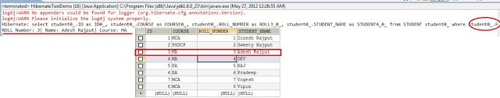

Criteria in Hibernate Example
In this tutorial of Criteria in Hibernate Example we will discuss about the Criteria API of hibernate it is using for fetching data from the database in the Hibernate.
There are three way to pulling data from the database in the Hibernate.
- Using session methods(get() and load() methods) -limited control to accessing data
- Using HQL – Slightly more control using where clause and other clauses but there are some problems here… is more complicated to maintain in case of bigger queries with lots of clauses.
- Using Criteria API

WHAT IS CRITERIA API?
The API (Application Programming Interface) of Hibernate Criteria provides an elegant way of building dynamic query on the persistence database.
The hibernate criteria API is very Simplified API for fetching data from Criterion objects. The criteria API is an alternative of HQL (Hibernate Query Language) queries. It is more powerful and flexible for writing tricky criteria functions and dynamic queries

1. Using Criteria API to create criteria:
Criteria criteria = session.createCriteria(Student.class);

2. The Criteria API supports all the comparision operators
such as =, <, >, >=,=<, etc in the supported Expression class eq(), lt(), gt(), le() , ge() respectively.
Criteria criteria = session.createCriteria(Student.class);
criteria.add(Restrictions.eq("studentName", "Dinesh Rajput"));
criteria.add(Restrictions.le("rollNumber", 1));

3. Criteria ordering query
The result is sort by “studentName” in ascending order.
Criteria criteria = session.createCriteria(Student.class);
criteria.addOrder(Order.asc("studentName"));
The result is sort by “studentName” in descending order.
Criteria criteria = session.createCriteria(Student.class);
criteria.addOrder(Order.desc("studentName"));

4. Criteria paging the result
Criteria provide some functions to make pagination extremely easy. Starting from the 5th record, and retrieve the next 10 records from database.
Criteria criteria = session.createCriteria(Student.class);
criteria.setMaxResults(10);
criteria.setFirstResult(5);

Problem with Criteria API
1. Performance issue
You have no way to control the SQL query generated by Hibernate, if the generated query is slow, you are very hard to tune the query, and your database administrator may not like it.
2. Maintenance issue
All the SQL queries are scattered through the Java code, when a query went wrong, you may spend time to find the problem query in your application. On the others hand, named queries stored in the Hibernate mapping files are much more easier to maintain.
public static void main(String[] args)
{
SessionFactory sessionFactory = new AnnotationConfiguration().configure().buildSessionFactory();
Session session = sessionFactory.openSession();
session.beginTransaction();
Criteria criteria = session.createCriteria(Student.class);
criteria.add(Restrictions.eq("studentName", "Dinesh Rajput"));
List students = criteria.list();
for(Student student : students)
{
System.out.println(student);
}
session.getTransaction().commit();
session.close();
}
}
Output:
log4j:WARN No appenders could be found for logger (org.hibernate.cfg.annotations.Version).
log4j:WARN Please initialize the log4j system properly.
Hibernate: select this_.ID as ID0_0_, this_.COURSE as COURSE0_0_, this_.ROLL_NUMBER as ROLL3_0_0_, this_.STUDENT_NAME as STUDENT4_0_0_ from STUDENT this_ where this_.STUDENT_NAME=?
ROLL Number: 1| Name: Dinesh Rajput| Course: MCA
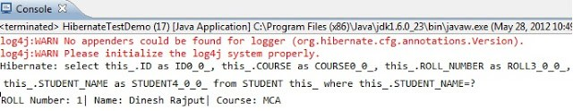

Restrictions in Hibernate
In this tutorial, you will see the use of Restrictions class in java. It is used to restrict the retrieval of data from database.
Syntax:
Criteria criteria = session.createCriteria(Model.class);
criteria.add(Restrictions.eq(propertyName, propertyValue));

Criteria restrictions query

The Restrictions class provide many methods to do the comparison operation.

Restrictions.eq
This is used to apply an “equal” constraint to the named property.
Simple SQL query >>
SELECT * FROM student WHERE rollNumber = 3;
Above query in Criteria API >>
Criteria criteria = session.createCriteria(Student.class);
criteria.add(Restrictions.eq("rollNumber", 3));
List list = criteria.list();
Restrictions.lt
This is used to apply a “less than” constraint to the named property.
Simple SQL query >>
SELECT * FROM student WHERE rollNumber < 3;
Above query in Criteria API >>
Criteria criteria = session.createCriteria(Student.class);
criteria.add(Restrictions.lt("rollNumber", 3));
List list = criteria.list();

Restrictions.gt
This is used to apply a “greater than” constraint to the named property.
Simple SQL query >>
SELECT * FROM student WHERE rollNumber > 3;
Above query in Criteria API >>
Criteria criteria = session.createCriteria(Student.class);
criteria.add(Restrictions.gt("rollNumber", 3));
List list = criteria.list();

Restrictions.le
This is used to apply a “less than or equal” constraint to the named property.
Simple SQL query >>
SELECT * FROM student WHERE rollNumber <= 3;
Above query in Criteria API >>
Criteria criteria = session.createCriteria(Student.class);
criteria.add(Restrictions.le("rollNumber", 3));
List list = criteria.list();

Restrictions.ge
This is used to apply a “greater than or equal” constraint to the named property.
Simple SQL query >>
SELECT * FROM student WHERE rollNumber >= 3;
Above query in Criteria API >>
Criteria criteria = session.createCriteria(Student.class);
criteria.add(Restrictions.ge("rollNumber", 3));
List list = criteria.list();

Restrictions.ne
This is used to apply a “not equal” constraint to the named property.
Simple SQL query >>
SELECT * FROM student WHERE rollNumber <> 3;
Above query in Criteria API >>
Criteria criteria = session.createCriteria(Student.class);
criteria.add(Restrictions.ne("rollNumber", 3));
List list = criteria.list();

Restrictions.in
This is used to apply an “in” constraint to the named property.
Simple SQL query >>
SELECT * FROM student WHERE rollNumber IN (3,5,7);
Above query in Criteria API >>
Criteria criteria = session.createCriteria(Student.class);
criteria.add(Restrictions.in("rollNumber", new Integer[]{3,5,7}));
List list = criteria.list();

Restrictions.or
This returns the disjunction of two expressions.
Simple SQL query >>
SELECT * FROM student WHERE rollNumber > 3 OR course='MA';
Above query in Criteria API >>
Criteria criteria = session.createCriteria(Student.class);
criteria.add(Restrictions.or(Restrictions.gt("rollNumber", 3), Restrictions.eq("course", "MA"));
List list = criteria.list();

Restrictions.not
This returns the negation of an expression.
Simple SQL query >>
SELECT * FROM student WHERE rollNumber NOT IN (3,5,7);
Above query in Criteria API >>
Criteria criteria = session.createCriteria(Student.class);
criteria.add(Restrictions.not(Restrictions.in("rollNumber", new Integer[]{3,5,7})));
List list = criteria.list();

Restrictions.like
This is used to apply a “like” constraint to the named property.
Simple SQL query >>
SELECT * FROM student WHERE studentName LIKE %RAJPUT%;
Above query in Criteria API >>
Criteria criteria = session.createCriteria(Student.class);
criteria.add(Restrictions.like("studentName", "%RAJPUT%"));
List list = criteria.list();

Restrictions.isNull
This is used to apply an “is null” constraint to the named property.
Simple SQL query >>
SELECT * FROM student WHERE studentName IS NULL;
Above query in Criteria API >>
Criteria criteria = session.createCriteria(Student.class);
criteria.add(Restrictions.isNull("studentName"));
List list = criteria.list();

Restrictions.isNotNull
This is used to apply an “is not null” constraint to the named property.
Simple SQL query >>
SELECT * FROM student WHERE studentName IS NOT NULL;
Above query in Criteria API >>
Criteria criteria = session.createCriteria(Student.class);
criteria.add(Restrictions.isNotNull("studentName"));
List list = criteria.list();

Restriction.between
This is used to apply a “between” constraint to the named property.
Simple SQL query >>
SELECT * FROM student WHERE rollNumber BETWEEN (3,7);
Above query in Criteria API >>
Criteria criteria = session.createCriteria(Student.class);
criteria.add(Restrictions.between("rollNumber", 3, 7));
List list = criteria.list();

Restriction.allEq
This is used to apply an “equals” constraint to each property in the key set of a Map.
Simple SQL query >>
SELECT * FROM user WHERE userName = +userName AND userPassword = +userPassword;
Above query in Criteria API >>
Map map = new HashMap();
map.put("username", username);
map.put("userPassword", userPassword);
Criteria criteria = session.createCriteria(User.class);
criteria.add(Restrictions.allEq(map));
List list = criteria.uniqueResult();

https://www.onlinetutorialspoint.com/hibernate-tutorials

Hibernate Projection with Example

If we want to read a partial entity (selected columns) from the database, hibernate has provided us with a Projection interface.

Hibernate Projection :
- Projection is an interface in Hibernate; it is coming from org.hibernate.criterion package.
- Projection can be applied to the Criteria query.
- Projection is an Object-Oriented Representation of a query result set.
- Hibernate Projection is used to read a partial entity from the database.
- If we want to read more than one property from the database, then we have to add Projection objects to ProjectionList, and then we need to set ProjectionList object to Criteria.

Simple Hibernate Projection Example :
The following code is to read the employee name column from the employee table. It will get all the employeNames from the employee table.

Criteria criteria = session.createCriteria(Employee.class);
Projection projection = Projections.property("employeeName");
criteria.setProjection(projection);
List list = criteria.list();

The equal SQL query is:
select ename from employee;

Multiple Hibernate Projection Example :

If we want to read more than 1 column (employeeName, salary) with projections, we should have to use ProjectinList class. We should prepare all projections and bind all projections into a single ProjectionList like below.
Criteria criteria = session.createCriteria(Employee.class);
Projection projection = Projections.property("salary");
Projection projection2 = Projections.property("departmentId");
Projection projection3 = Projections.property("employeeName");
ProjectionList pList = Projections.projectionList();
pList.add(projection);
pList.add(projection2);
pList.add(projection3);
criteria.setProjection(pList);
List list = criteria.list();
On the above example, we will get the salary, departmentId and employeeName from the employee table.

The equal SQL query is:
select sal,deptid,ename from emp;

Caching in Hibernate: First Level and Second Level Cache in Hibernate
In earlier we said that hibernate much more than an ORM tool i.e. Hibernate provide the lots of other features. In which Cache is very important feature one of them. Hibernate is actually a very powerful, consistent, and reliable database mapping tool. Mapping between objects in Java to relational databases has many facets that you must be aware of. Hibernate does a particularly good job of making the process simple to start, and providing the facilities to allow it to scale well and meet exceedingly complex mapping demands.

Caching in Hibernate
Caching is all about application performance optimization and it sits between your application and the database to avoid the number of database hits as many as possible to give a better performance for performance critical applications.
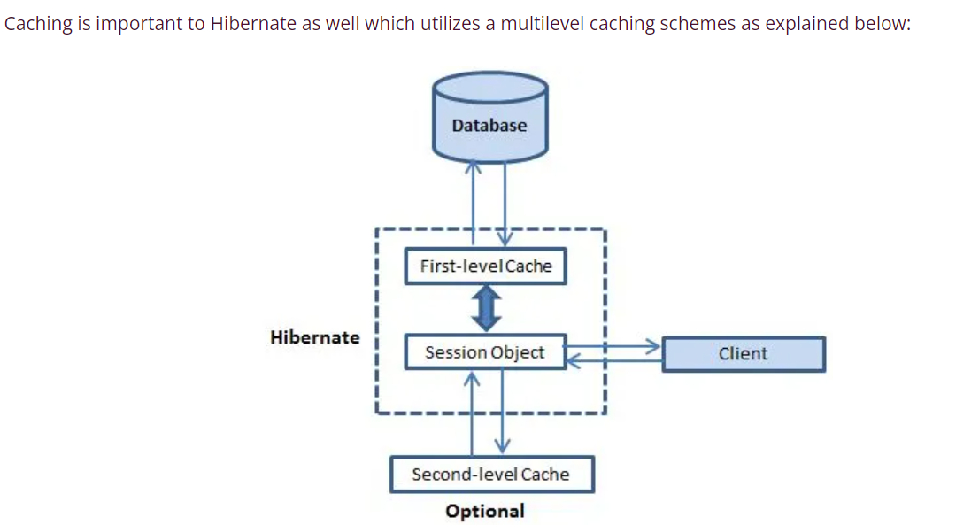
One of the primary concerns of mappings between a database and our Java application is performance. This is the common concern of the all guys who working with hibernate and spent the more time in ORM tools for performance-enhancing changes to particular queries and retrievals. Today I want to discuss about some facets of the Hibernate infrastructure that are implemented to handle certain performance concerns –
- The first-level cache – Session (Earlier hibernate already provide this level of cache)
- The second-level cache –Session-factory-level cache
- and the query cache.

The first-level cache:
The first level cache type is the session cache. The session cache caches object within the current session but this is not enough for long level i.e. session factory scope.

The second-level cache:
The second-level cache is called ‘second-level’ because there is already a cache operating for you in Hibernate for the duration you have a session open. A Hibernate Session is a transaction-level cache of persistent data. It is possible to configure a SessionFactory-level cache on a class-by-class and collection-by-collection basis.
second-level cache
— Across sessions in an Application
— Across applications (different applications on same servers with same database)
— Across clusters (different applications on different servers with same database)
NOTE: Be careful Caches are never aware of changes made to the persistent store by another application i.e. suppose one application deploy one server with using hibernate and get the data from database and put to the cache for further using purpose but another application deployed another server which does not using any ORM tool so it does mot know about Cache and direct interacting with database and may be update data of database. Now data in Cache is invalid.

Hibernate uses first-level cache by default and you have nothing to do to use first-level cache. Let’s go straight to the optional second-level cache. Not all classes benefit from caching, so it’s important to be able to disable the second-level cache.
The ‘second-level’ cache exists as long as the session factory is alive. The second-level cache holds on to the ‘data’ for all properties and associations (and collections if requested) for individual entities that are marked to be cached.
Advertisements
In hibernate configuration file (hibernate.cfg.xml) we wrote the following line.
For Disabling the second level of cache we have to made following change to hibernate configuration file.
<!-- Disable the second-level cache -->
<property name="cache.provider_class">org.hibernate.cache.NoCacheProvider</property>

For Enabling the second level of cache we have to made following change to hibernate configuration file.
<!-- Enable the second-level cache -->
<property name="cache.use_second_level_cache">true</property>
<property name="cache.provider_class">org.hibernate.cache.EhCacheProvider</property>
1. Cache Strategy using with Annotation as some changes made to the Model class also.
@Cacheable
@Cache(usage = CacheConcurrencyStrategy.READ_ONLY)
@Entity
@Table(name="STUDENT")
public class Student implements Serializable
{
....
2. Cache Strategy using with Mapping file(.hbm.xml) .
<hibernate-mapping>
<class name="Student" table="STUDENT">

This class contains the student detail.

<cache usage="read-only">
<id column="ID" name="id" type="java.lang.Long">
<generator class="native">
</generator></id>
<property column="STUDENT_NAME" name="studentName" type="java.lang.String">
<property column="lCOURSE" name="course" type="java.lang.String">
<property column="ROLL_NUMBER" name="rollNumber" type="java.lang.Long">
</property></property></property></cache></class>
</hibernate-mapping>

Concurrency strategies:
A concurrency strategy is a mediator which responsible for storing items of data in the cache and retrieving them from the cache. If you are going to enable a second-level cache, you will have to decide, for each persistent class and collection, which cache concurrency strategy to use.
- Transactional: Use this strategy for read-mostly data where it is critical to prevent stale data in concurrent transactions,in the rare case of an update.
- Read-write: Again use this strategy for read-mostly data where it is critical to prevent stale data in concurrent transactions,in the rare case of an update.
- Nonstrict-read-write: This strategy makes no guarantee of consistency between the cache and the database. Use this strategy if data hardly ever changes and a small likelihood of stale data is not of critical concern.
- Read-only: A concurrency strategy suitable for data which never changes. Use it for reference data only.

Using Query Cache in Hibernate
In current chapter I am going to explain how to use Hibernate Query Cache to avoid amount of traffic between your application and database. The query cache is responsible for caching the results of queries. Let us have a look how Hibernate uses the query cache to retrieve objects.
Note that the query cache does not cache the state of the actual entities in the result set; it caches only identifier values and results of value type. So the query cache should always be used in conjunction with the second-level cache

How the Query Cache Works:
Query query = session.createQuery("from Student as student where student.id = ? and student.studentName = ?");
query.setInt(0, Integer.valueOf(1));
query.setString(1, "Dinesh Rajput");
query.setCacheable(true);
List l = query.list();
The query cache works something like this:
*----------------------------------------------------------------------------------------*
| Query Cache |
|----------------------------------------------------------------------------------------|
| ["from Student as student where student.id = ? and student.studentName = ?", [ 1 , "Dinesh Rajput"] ] -> [ 2 ] ] |
*----------------------------------------------------------------------------------------*
The combination of the query and the values provided as parameters to that query is used as a key, and the value is the list of identifiers for that query. Note that this becomes more complex from an internal perspective as you begin to consider that a query can have an effect of altering associations to objects returned that query; not to mention the fact that a query may not return whole objects, but may in fact only return scalar values (when you have supplied a select clause for instance). That being said, this is a sound and reliable way to think of the query cache conceptually.

Using the query cache
Two hibernate properties control whether the query cache is enabled:
- hibernate.cache.use_second_level_cache=true|false
- hibernate.cache.use_query_cache=true|false

The first turns on the second level cache in general and the second turns on the query cache regions. If the second is set to false, the query and timestamp cache regions are not created or used.
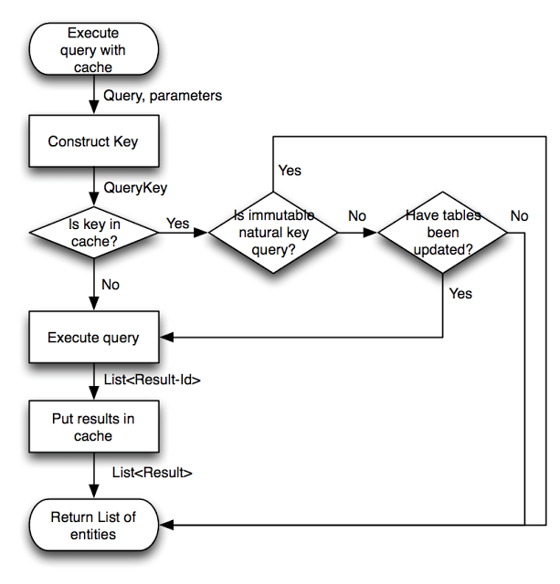

Hibernate Batch Processing

Suppose there is one situation in which you have to insert 1000000 records in to database in a time. So what to do in this situation…

In Native Solution in the Hibernate
Session session = sessionFactory.openSession();
Transaction tx = session.beginTransaction();
for ( int i=0; i<1000000; i++ )
{
Student student = new Student(.....);
session.save(student);
}
tx.commit();
session.close();
Because by default, Hibernate will cache all the persisted objects in the session-level cache and ultimately your application would fall over with an OutOfMemoryException somewhere around the 50,000th row. You can resolve this problem if you are using batch processing with Hibernate.
To use the batch processing feature, first set hibernate.jdbc.batch_size as batch size to a number either at 20 or 50 depending on object size. This will tell the hibernate container that every X rows to be inserted as batch. To implement this in your code we would need to do little modification as follows:
Session session = SessionFactory.openSession();
Transaction tx = session.beginTransaction();
for ( int i=0; i<1000000; i++ )
{
Student student = new Student(.....);
session.save(employee);
if( i % 50 == 0 ) // Same as the JDBC batch size
{
//flush a batch of inserts and release memory:
session.flush();
session.clear();
}
}
tx.commit();
session.close();
Above code will work fine for the INSERT operation, but if you want to make UPDATE operation then you can achieve using the following code:
Session session = sessionFactory.openSession();
Transaction tx = session.beginTransaction();
ScrollableResults studentCursor = session.createQuery("FROM STUDENT").scroll();
int count = 0;
while(studentCursor .next())
{
Student student = (Student) studentCursor.get(0);
student.setName("DEV");
seession.update(student);
if ( ++count % 50 == 0 ) {
session.flush();
session.clear();
}
}
tx.commit();
session.close();

In Batch Processing Solution in the Hibernate
If you are undertaking batch processing you will need to enable the use of JDBC batching. This is absolutely essential if you want to achieve optimal performance. Set the JDBC batch size to a reasonable number (10-50).
hibernate.jdbc.batch_size 50
You can also do this kind of work in a process where interaction with the second-level cache is completely disabled:
hibernate.cache.use_second_level_cache false
hibernate.cfg.xml
<hibernate-configuration>
<session-factory>
<property name="connection.driver_class">com.mysql.jdbc.Driver</property>
<property name="connection.url">jdbc:mysql://localhost:3306/hibernateDB2</property>
<property name="connection.username">root</property>
<property name="connection.password">root</property>
<property name="connection.pool_size">1</property>
<property name="hibernate.jdbc.batch_size"> 50 </property>
<property name="dialect">org.hibernate.dialect.MySQLDialect</property>
<property name="current_session_context_class">thread</property>
<property name="hibernate.cache.use_second_level_cache">false</property>
<property name="cache.provider_class">org.hibernate.cache.EhCacheProvider</property>
<property name="show_sql">true</property>
<property name="hbm2ddl.auto">update</property>
<mapping class="com.sdnext.hibernate.tutorial.dto.Student">
</mapping></session-factory>
</hibernate-configuration>
Student.java
package com.sdnext.hibernate.tutorial.dto;

import java.io.Serializable;

import javax.persistence.Column;
import javax.persistence.Entity;
import javax.persistence.GeneratedValue;
import javax.persistence.GenerationType;
import javax.persistence.Id;
import javax.persistence.Table;

@Entity
@Table(name="STUDENT")
public class Student implements Serializable
{
/**
* serialVersionUID
*/
private static final long serialVersionUID = 8633415090390966715L;
@Id
@Column(name="ID")
@GeneratedValue(strategy=GenerationType.AUTO)
private int id;
@Column(name="STUDENT_NAME")
private String studentName;
@Column(name="ROLL_NUMBER")
private int rollNumber;
@Column(name="COURSE")
private String course;
public int getId() {
return id;
}
public void setId(int id) {
this.id = id;
}
public String getStudentName() {
return studentName;
}
public void setStudentName(String studentName) {
this.studentName = studentName;
}
public int getRollNumber() {
return rollNumber;
}
public void setRollNumber(int rollNumber) {
this.rollNumber = rollNumber;
}
public String getCourse() {
return course;
}
public void setCourse(String course) {
this.course = course;
}
public String toString()
{
return "ROLL Number: "+rollNumber+"| Name: "+studentName+"| Course: "+course;
}
}
HibernateTestDemo.java
Advertisements
package com.sdnext.hibernate.tutorial;

import org.hibernate.Session;
import org.hibernate.SessionFactory;
import org.hibernate.Transaction;
import org.hibernate.cfg.AnnotationConfiguration;

import com.sdnext.hibernate.tutorial.dto.Student;

public class HibernateTestDemo {

/**
* @param args
*/
public static void main(String[] args)
{
SessionFactory sessionFactory = new AnnotationConfiguration().configure().buildSessionFactory();
Session session = sessionFactory.openSession();
Transaction transaction = session.beginTransaction();

for ( int i=0; i<100000; i++ )
{
String studentName = "DINESH " + i;
int rollNumber = 9 + i;
String course = "MCA " + i;
Student student = new Student();
student.setStudentName(studentName);
student.setRollNumber(rollNumber);
student.setCourse(course);
session.save(student);
if( i % 50 == 0 )
{
session.flush();
session.clear();
}
}
transaction.commit();
session.close();
}

}
Output: ……………………………
…………………………….
………………………………
Hibernate: insert into STUDENT (COURSE, ROLL_NUMBER, STUDENT_NAME) values (?, ?, ?) Hibernate: insert into STUDENT (COURSE, ROLL_NUMBER, STUDENT_NAME) values (?, ?, ?) Hibernate: insert into STUDENT (COURSE, ROLL_NUMBER, STUDENT_NAME) values (?, ?, ?) Hibernate: insert into STUDENT (COURSE, ROLL_NUMBER, STUDENT_NAME) values (?, ?, ?) Hibernate: insert into STUDENT (COURSE, ROLL_NUMBER, STUDENT_NAME) values (?, ?, ?) Hibernate: insert into STUDENT (COURSE, ROLL_NUMBER, STUDENT_NAME) values (?, ?, ?) Hibernate: insert into STUDENT (COURSE, ROLL_NUMBER, STUDENT_NAME) values (?, ?, ?) Hibernate: insert into STUDENT (COURSE, ROLL_NUMBER, STUDENT_NAME) values (?, ?, ?) Hibernate: insert into STUDENT (COURSE, ROLL_NUMBER, STUDENT_NAME) values (?, ?, ?) Hibernate: insert into STUDENT (COURSE, ROLL_NUMBER, STUDENT_NAME) values (?, ?, ?) Hibernate: insert into STUDENT (COURSE, ROLL_NUMBER, STUDENT_NAME) values (?, ?, ?) Hibernate: insert into STUDENT (COURSE, ROLL_NUMBER, STUDENT_NAME) values (?, ?, ?) Hibernate: insert into STUDENT (COURSE, ROLL_NUMBER, STUDENT_NAME) values (?, ?, ?) Hibernate: insert into STUDENT (COURSE, ROLL_NUMBER, STUDENT_NAME) values (?, ?, ?) ………………………………
……………………………
…………………………
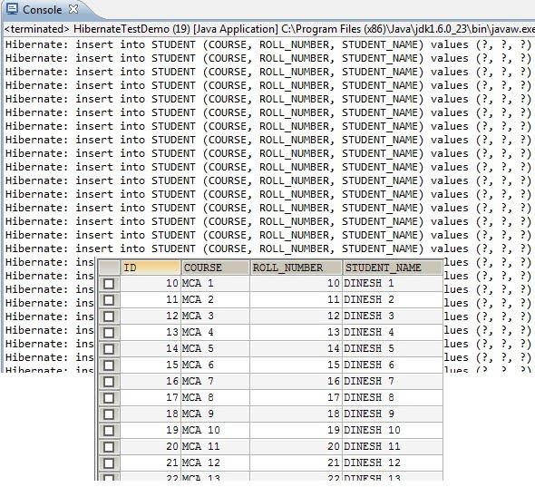
This will create 100000 records in STUDENT table.
Hibernate batch processing is powerful but it has many pitfalls that developers must be aware of in order to use it properly and efficiently. Most people who use batch probably find out about it by trying to perform a large operation and finding out the hard way why batching is needed. They run out of memory. Once this is resolved they assume that batching is working properly. The problem is that even if you are flushing your first level cache, you may not be batching your SQL statements.
Hibernate flushes by default for the following reasons:
1. Before some queries
2. When commit() is executed
3. When session.flush() is executed
The thing to note here is that until the session is flushed, every persistent object is placed into the first level cache (your JVM’s memory). So if you are iterating over a million objects you will have at least a million objects in memory.
To avoid this problem you need to call the flush() and then clear() method on the session at regular intervals. Hibernate documentation recommends that you flush every n records where n is equal to the hibernate.jdbc.batch_size parameter. A Hibernate Batch example shows a trivial batch process.
There are two reasons for batching your hibernate database interactions. The first is to maintain a reasonable first level cache size so that you do not run out memory. The second is that you want to batch the inserts and updates so that they are executed efficiently by the database. The example above will accomplish the first goal but not the second.
Student student = new Student();
Address address = new Address();
student.setName("DINESH RAJPUT");
address.setCity("DELHI");
student.setAddress(address);
session.save(student);
The problem is Hibernate looks at each SQL statement and checks to see if it is the same statement as the previously executed statement. If they are and if it hasn’t reached the batch_size it will batch those two statements together using JDBC2 batch. However, if your statements look like the example above, hibernate will see alternating insert statements and will flush an individual insert statement for each record processed. So 1 million new students would equal a total of 2 million insert statements in this case. This is extremely bad for performance.
STEPS

Best Solution
After trying all possible solutions I finally found a solution to insert 100,000 rows under 5 seconds!
Things I tried:
1) Replaced hibernate/database's AUTOINCREMENT/GENERATED id's by self generated ID's using AtomicInteger
@Id
@GeneratedValue(strategy = GenerationType.SEQUENCE, generator = "seqGen")
@SequenceGenerator(name = "seqGen", sequenceName = "products_id_seq", allocationSize = 1)
2) Enabling batch_inserts with batch_size=50
3) Flushing cache after every 'batch_size' number of persist() calls
4) multithreading (did not attempt this one)
Finally what worked was using a native multi-insert query and inserting 1000 rows in one sql insert query instead of using persist() on every entity. For inserting 100,000 entities, I create a native query like this "INSERT into MyTable VALUES (x,x,x),(x,x,x).......(x,x,x)" [1000 row inserts in one sql insert query]
Now it takes around 3 seconds for inserting 100,000 records! So the bottleneck was the orm itself! For bulk inserts, the only thing that seems to work is native insert queries!

